Barcode Label Print Program

TelFar currently has a barcode label print program that only allows them to print one label at a time. What they need to have is the ability to generate these labels in a Batch similar to the standard label print program.

Below is the standard label print program that provides some parameters to select which labels you want to print.

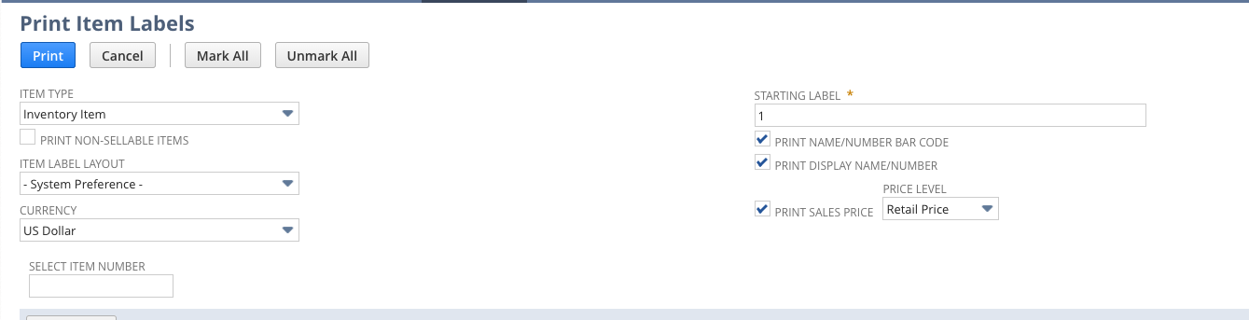

There is the option to select the Item Label Layout.

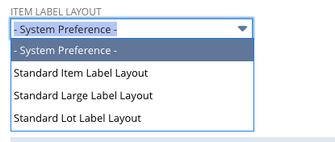

Their current customization is a button on the item form titled Print GTIN 12

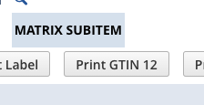

When they select this it bring them to another form to generate the PDF.

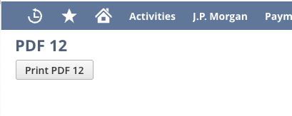

When they click this button they get the single label that is a custom format specific for Telfar.

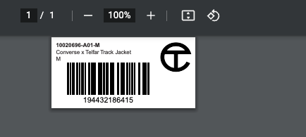

What they would like to do is have the ability to generate these labels for multiple items at one time, similar to the standard label print program.

This would most likely require a suitelet to allow the search capabilities, have the option to select which items they want to print the labels for (or have a Mark All button to select all results), and then submit to generate a label for all the items selected.

I will get the exact filter requirements, but can you please start to look into this suitelet to see what level of effort it would be? This has become a high priority for them.